Software Requirements Specification
for
Hotel Management System
Version 1.0 approved
Prepared by Mohamed Taha Salah Mohamed Heshmat Abdullah Ashraf Sharif Abdulrahman Gaber
ECU
5/22/2022
Table of Contents
Table of Contents ii
Revision History Error! Bookmark not defined.
1. Introduction 1
1.1 Purpose 1
1.2 Document Conventions 1
1.3 Intended Audience and Reading Suggestions 1
1.4 Product Scope 1
1.5 References 2
2. Overall Description 3
2.1 Product Perspective 3
2.2 Product Functions 4
2.3 User Classes and Characteristics 5
2.4 Operating Environment 19
2.5 Design and Implementation Constraints Error! Bookmark not defined.
2.6 User Documentation Error! Bookmark not defined.
2.7 Assumptions and Dependencies 19
3. External Interface Requirements 20
3.1 User Interfaces Error! Bookmark not defined.
3.2 Hardware Interfaces 20
3.3 Software Interfaces Error! Bookmark not defined.
3.4 Communications Interfaces 20
4. System Features 20
4.1 System Feature 1 Error! Bookmark not defined.
4.2 System Feature 2 (and so on) Error! Bookmark not defined.
5. Other Nonfunctional Requirements 23
5.1 Performance Requirements 23
5.2 Safety Requirements Error! Bookmark not defined.
5.3 Security Requirements 23
5.4 Software Quality Attributes Error! Bookmark not defined.
5.5 Business Rules 24
Appendix A: Glossary 24

Table of figers

Context Diagram Error! Bookmark not defined.
Architectural design Error! Bookmark not defined.
Use Case Error! Bookmark not defined.
Class Diagram Error! Bookmark not defined.
State Diagram Error! Bookmark not defined.
Activity(1) Error! Bookmark not defined.
Activity(2) Error! Bookmark not defined.
Activity(3) Error! Bookmark not defined.
Activity(4) Error! Bookmark not defined.
Activity(5) Error! Bookmark not defined.
Activity(6) Error! Bookmark not defined.
Activity(7) Error! Bookmark not defined.
Activity(8) Error! Bookmark not defined.
Activity(9) Error! Bookmark not defined.
Activity(10) Error! Bookmark not defined.
Sequence(1) Error! Bookmark not defined.
Sequence(2) Error! Bookmark not defined.
Sequence(3) Error! Bookmark not defined.
Sequence(4) Error! Bookmark not defined.

Introduction

Purpose (Abdullah Ashraf)
The main purpose of hotel management is to ensure a continuous flow of visitors and guests to the hotel throughout the year, highlighting the variety of services and USPs and how they benefit from visiting guests through marketing initiatives. Moreover, it also implies qualitative leadership through innovative business strategies.
- Hotel management
- Finance
- Hospitality
- Supply Management
- House keeping
- Marketing and Accounts

Document Convention. (Abdelrahman Gaber)
- The documents is prepared using Microsoft Word 2019 and has used the font type ‘Arial’.
- The fixed font size that has been used to type this document is 11pt with 1.5 line space.
- It has used the italic property to set the heading of the document.
- Use case scenario is written according to Alistair Cockburn’s template.
- UML diagrams have been created according to UML 2.0 standards.
- Standards IEEE template is the template used to organize the appearance of the document.

Intended Audience and Reading Suggestions (Mohamed Taha Salah)
- The intended audience for this document will be the owner and a specific source
Staff like manager and receptionist at Radisson Blu Hotel and Project
Team for the purpose of information transmission and analysis.
- The SRS document can be used in any case in connection with the requirements
Project and solutions taken.
- The document will provide a clear idea of the system being built.
- A brief outline of the document is:
    - General description
    - System Features
    - External interface requirements
    - Non-functional requirements

Product Scope (Mohamed Heshmat)
- The software is a hotel management system, the purpose of the system is to create software that can be used in the hotel business that will contain all the features that a hotel company may need, but will also be a platform for expansion that will allow the developer to add additional features to the feature set.

- The benefit to business is that this software can be revised to add more efficient ways to improve the business backend. The goal of the whole project is to achieve all the necessary things in our analysis of Moscow and to have at least two that should be implemented in the system.
- The goal of the entire project is to create an extensible system with easy-to-read code and clearly defined classes that can be used as a platform to extend the feature set.

References
https://www.oracle.com/

https://www.xotels.com/

https://setupmyhotel.com/

https://www.academia.edu/

Overall Description

Product Perspective

Context Diagram

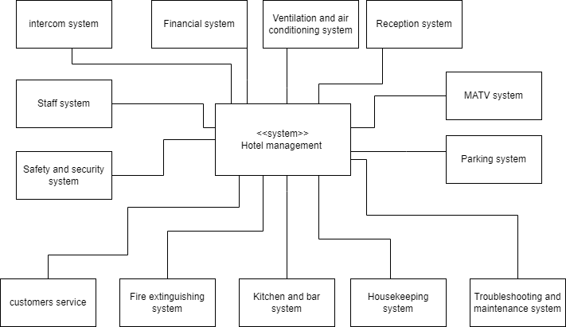

Architecture Design

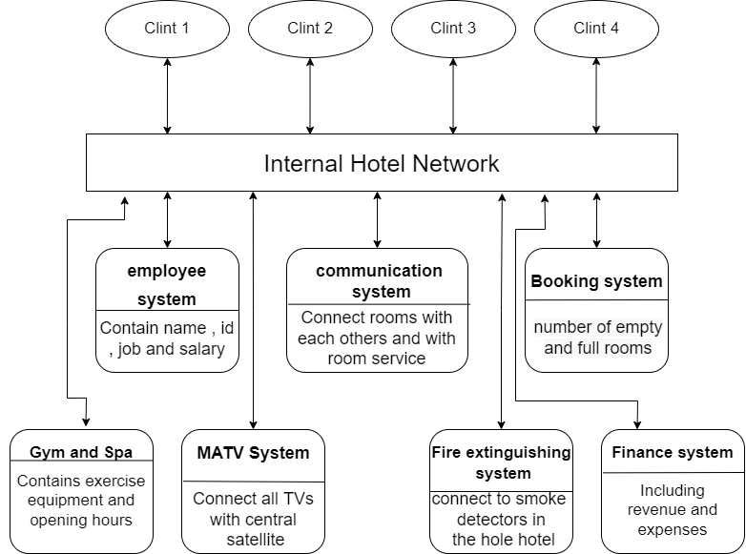

Product Functions

Use Case Diagram:

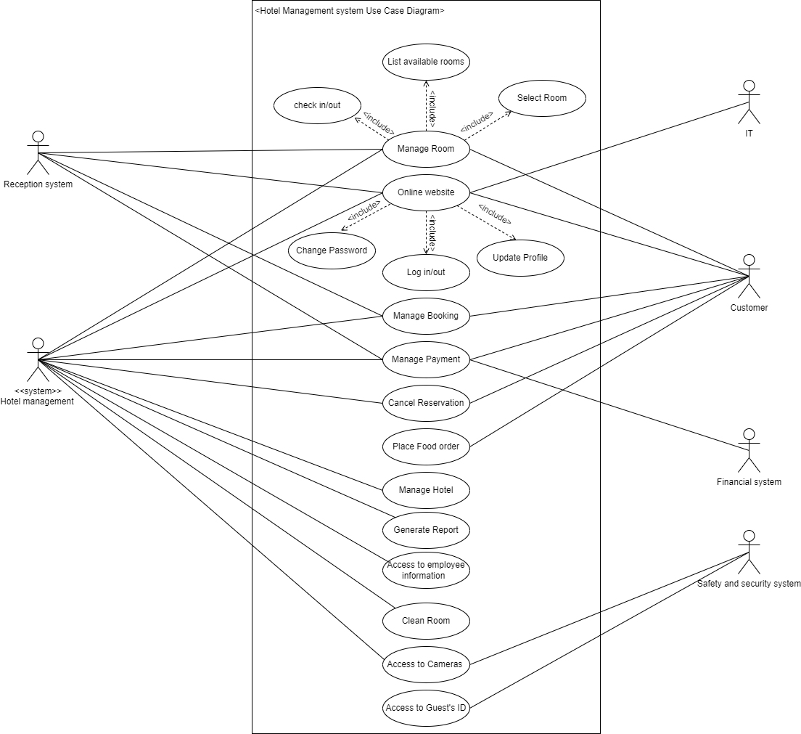

Class Diagram:

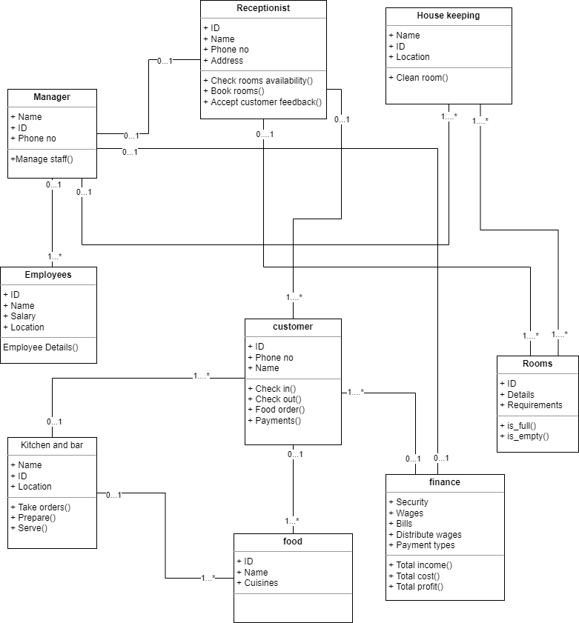

State Diagram:

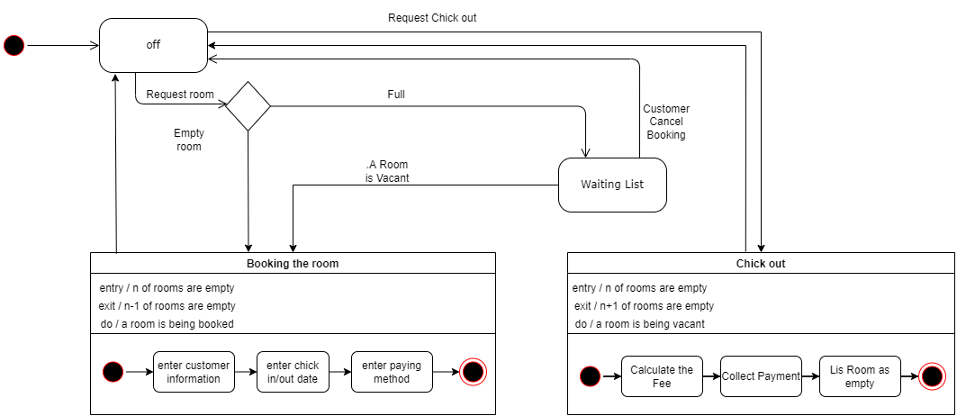

Activity Diagrams:

- All hotels in the group shall be linked administratively to a large server (Mohamed Taha Salah)

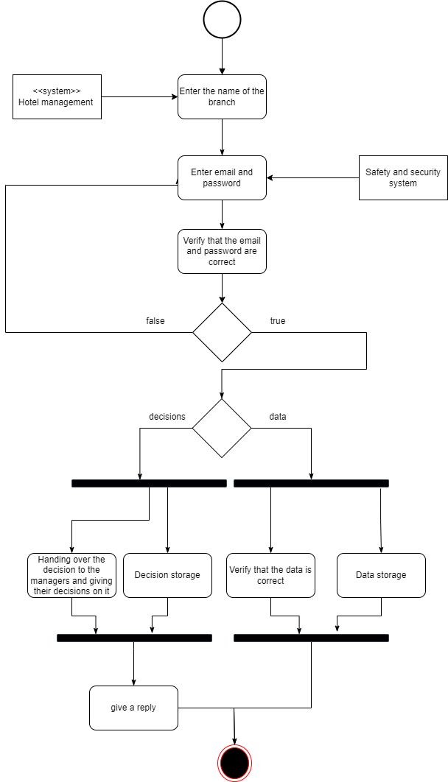

- The system shall have a site that the customer can book on (Mohamed Taha Salah)

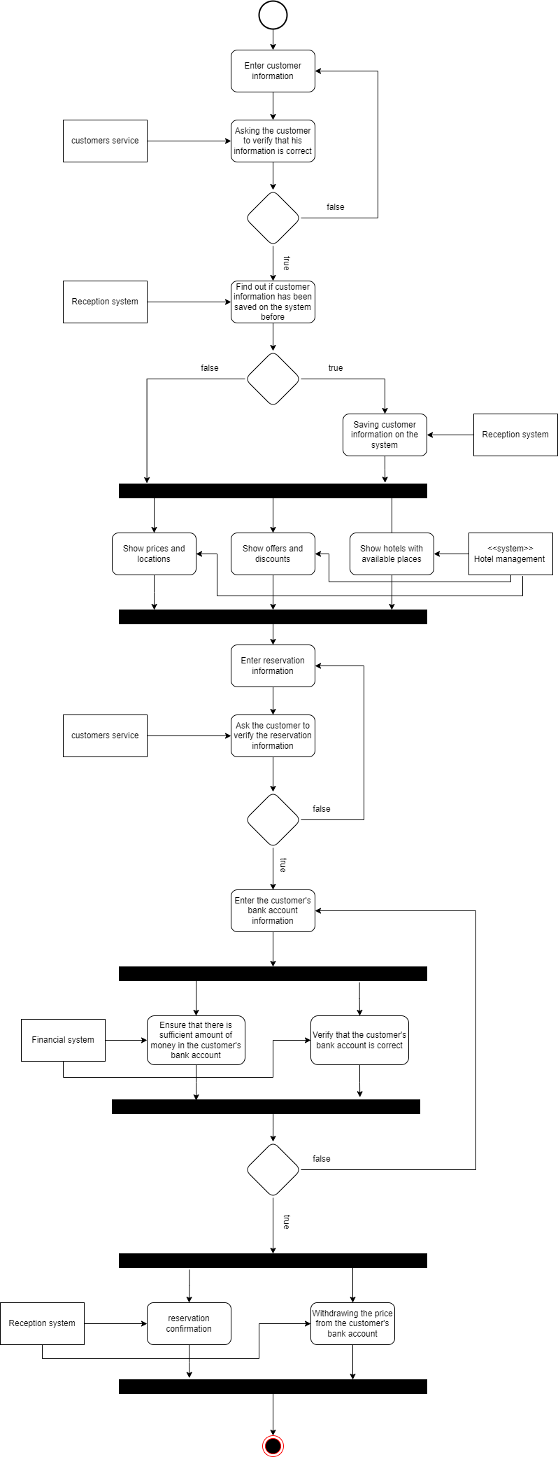
- The system shall distribute the Internet to all rooms without affecting the use of the Internet in one room over the rest of the rooms (Mohamed Taha Salah)

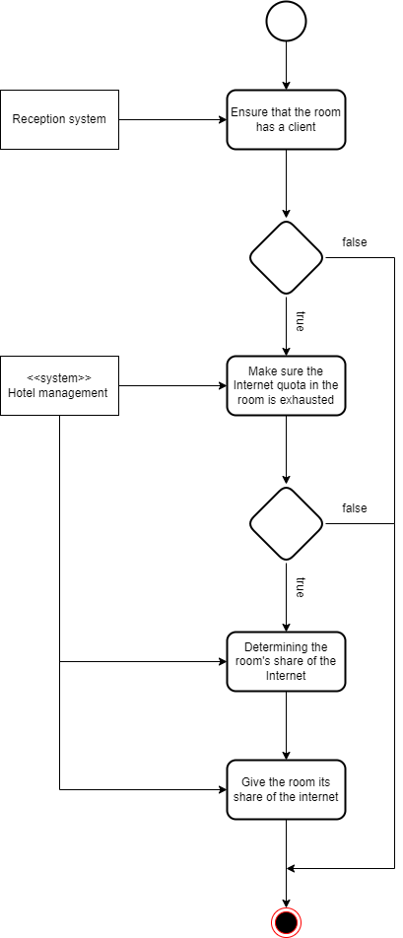

- The system shall have a storage system for resources (Mohamed Taha Salah)

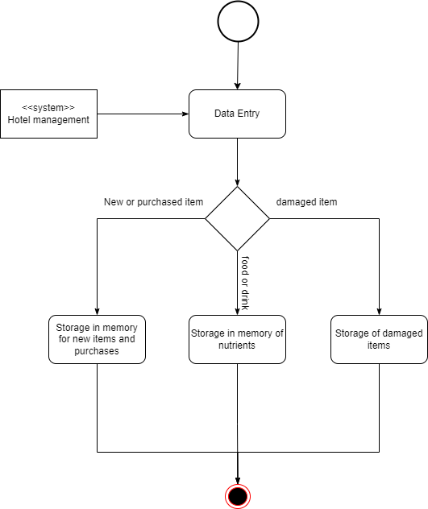

- the system shall include a Security system (Abdulrahman Gaber)

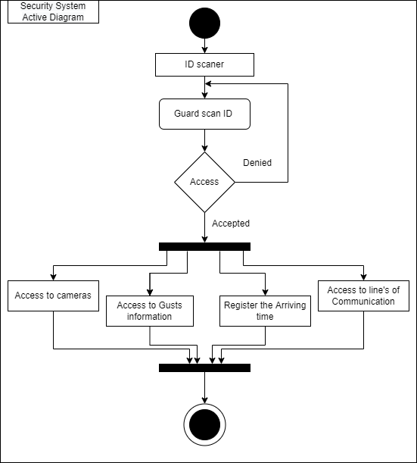

- the system shall include a Fire extinguishing system (Abdulrahman Gaber)

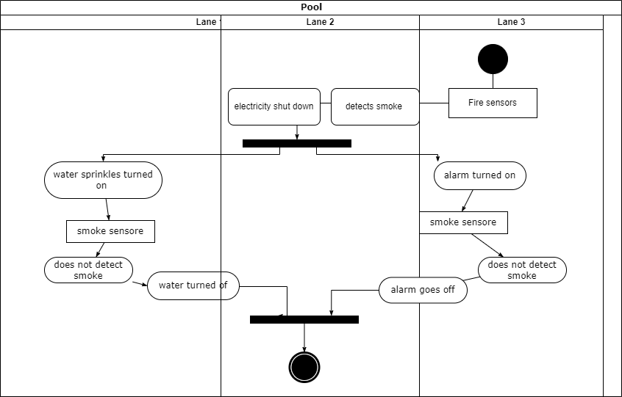
- Every room in the hotel shall have telephones linked to each other to facilitate the way of communication between guests and receptionists (Mohamed Heshmat)

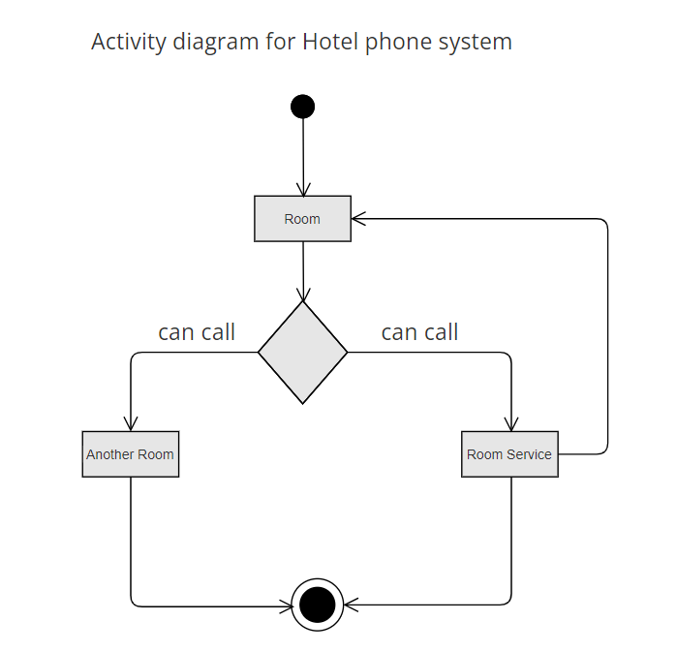

- A kitchen/restaurant system and administration shall be included in any hotel (Mohamed Heshmat)

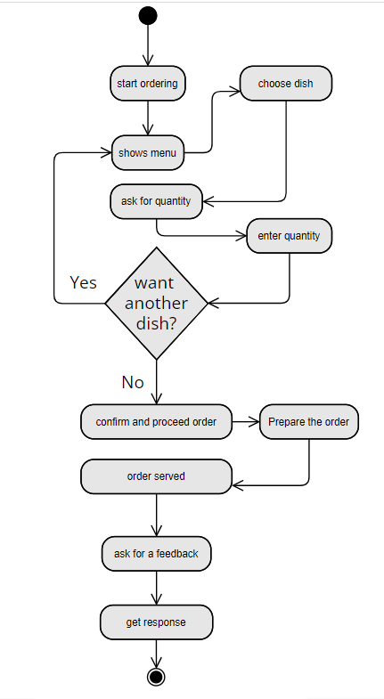

- The system shall include Wedding Hall (Abdullah Ashraf)

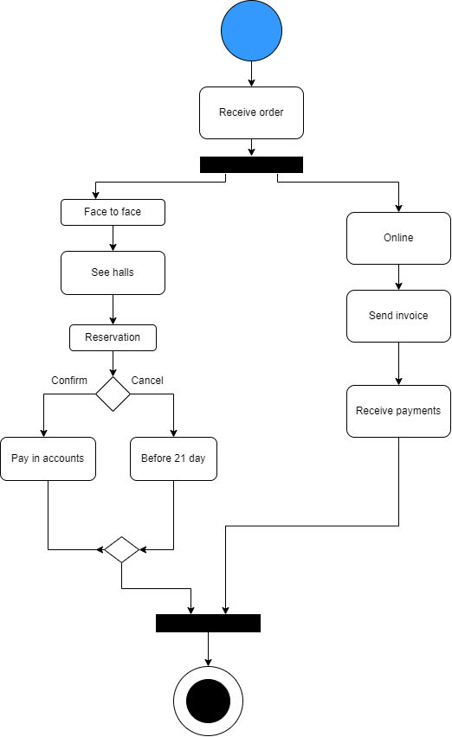

- The system shall include Valet parking (Abdullah Ashraf)

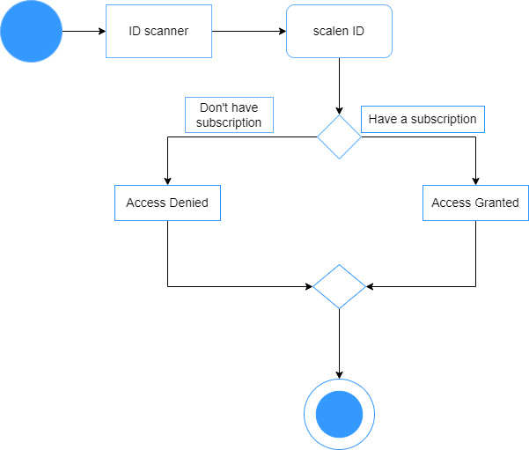
Sequence Diagrams:

- the system shall include a Security system (Abdulrahman Gaber)

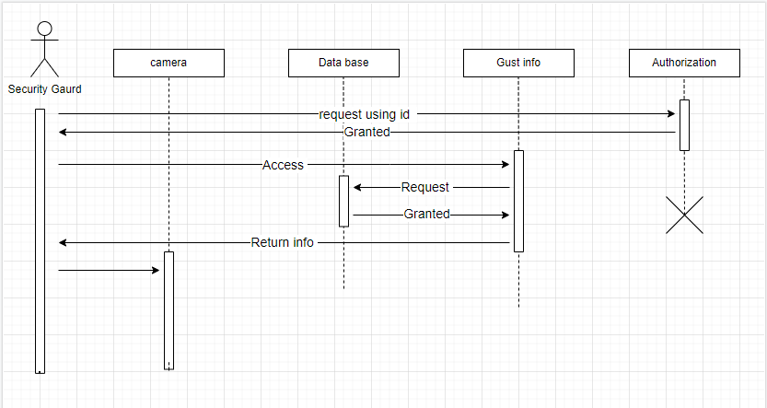

- The system shall have a site that the customer can book on (Mohamed Taha Salah)

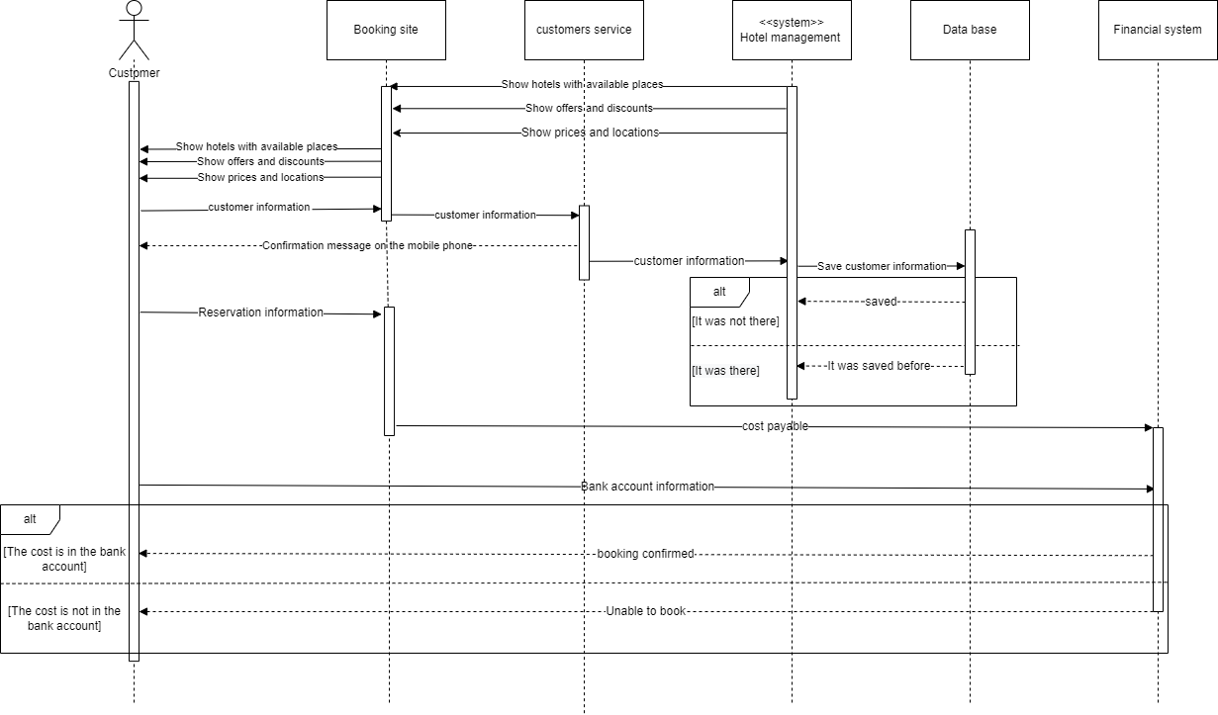
- The system shall include Wedding Hall (Abdullah Ashraf)

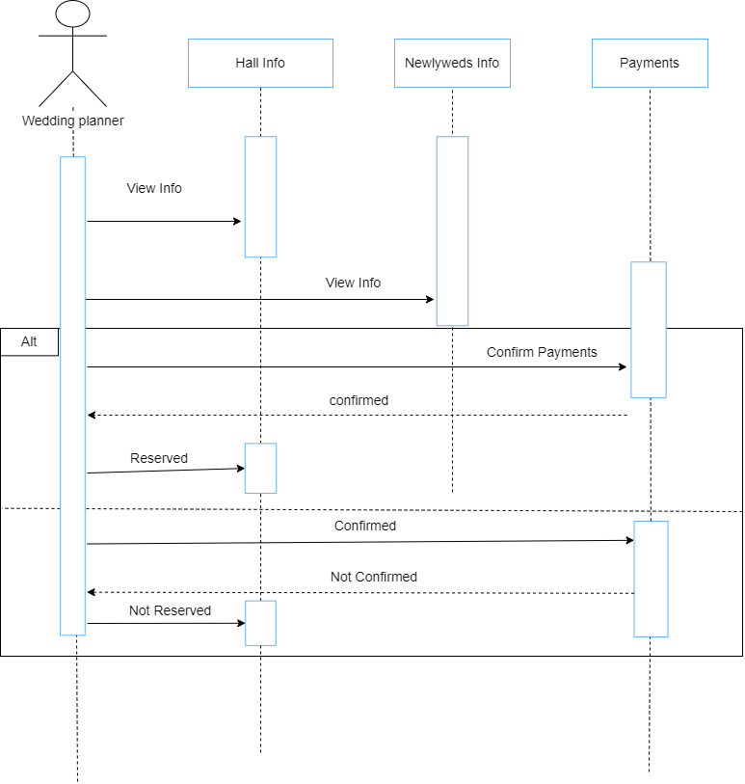

- A kitchen/restaurant system and administration shall be included in any hotel (Mohamed Heshmat)

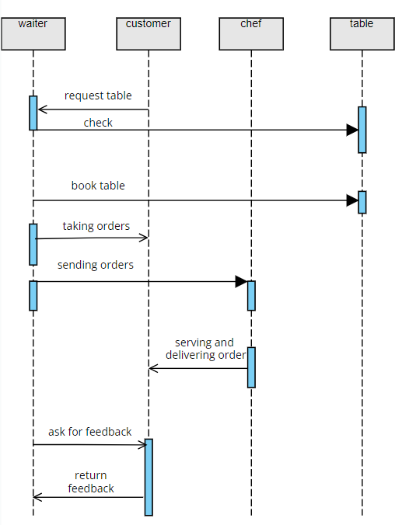

User Classes and Characteristics
- Manager: (View report, setup rooms)
- Receptionist: (manage booking, adding, cancelling)
- Customer: (Register, search rooms, confirm reservations, place food order)
- Finance: (Manage Payments)
- IT: (Online Website)

Operating Environment
The system will boot with Windows (8,9,10)

Assumptions and Dependencies
It is assumed that the developed system will work perfectly and will be developed in framework Windows as mentioned.

External Interface Requirements

Hardware Interfaces
Server device: Monitor → (Resolution: 1280 x 1024, Processors: Intel core I7 or snapdragon, RAM: 16GB, Disk space: 1TB)
Client device: Monitor → (Resolution: 1280 x 768, Processors: Intel core I5 or AMD, RAM: 4GB, Disk space: 512MB)

Communications Interfaces
The system shall be using HTTPS for communication over internet secure.

System Features

All hotels in the group shall be linked administratively to a large server (Mohamed Taha Salah)
4.1.1 We shall put a large server in the main branch and put a client in each of the other branches .
4.1.2 There should be someone in every branch to introduce management changes
Periodically every 24 hours on the server by the client.

The system shall have a site that the customer can book on (Mohamed Taha Salah)
4.2.1 The site shall have access to all hotels in the group to complete the customer's

4.2.2 The site should contain the reservation information of all hotels in the group, empty spaces, hotel locations, etc.

The system shall distribute the Internet to all rooms without affecting the use of the Internet in one room over the rest of the rooms (Mohamed Taha Salah)
4.3.1 The Internet shall be distributed evenly to all rooms, knowing that each room has a certain share of the Internet, so that if the Internet quota is spent in a particular room, it will not affect the rest of the other rooms.

The system shall have a storage system for resources (Mohamed Taha Salah)
We can divide the storage system into three divisions :

4.4.1 The system shall record and store damaged items for disposal or replacement.

4.4.2 The system shall record and store new items and new spare parts that are planned to be used if existing items are damaged.

4.4.3 The system shall record and store food, drink, vegetables, fruits and animals.

the system shall include a Housekeeping system (Abdulrahman Gaber)
4.5.1 that system shall include the name , salary and workhours of every employee

4.5.2 the system shall be connected to the room booking system to know when the room is going to be available for cleaning

4.5.3 The system shall include the tools used in cleaning and their costs

the system shall include a Security system (Abdulrahman Gaber)
4.6.1 the system shall have all the surveillance cameras connected together

4.6.2 The guards shall have a mean of communications between each other and an alarm system goes on when there is an emergency

4.6.3 An alarm shall be installed in every entrance that goes on when it detects a weapon of any means

the system shall include a Fire extinguishing system (Abdulrahman Gaber)
4.7.1 Smoke detectors shall be installed in each room and hallway

4.7.2 This system should also be connected to a water sprinklers

4.7.3 The number and location of Fire distinguishers shall be stored in the system

the system shall include a Employees system (Abdulrahman Gaber)
4.8.1 the system shall include the name , salary and workhours of every employee

4.8.2 System shall be able to calculate the overtime bonus if exists

4.8.3 System should include fingerprint device to know the time of attendance and departure of the employees

The hotel shall include MATV system (Mohamed Heshmat)
4.9.1 the system shall carry digital television signals through an aerial or satellite dish (both free-to view and subscription television), FM radio and DAB (Digital Audio Broadcasting).
4.9.2 the system shall be connected for all rooms in the hotel to let the guests watching whatever they want
4.9.3 The system shall include the possibility of modification /deletion/ addition to the channels on the system

A kitchen/restaurant system and administration shall be included in any hotel (Mohamed Heshmat)
4.11.1 The system shall have different types of cuisines from different regions around the world

4.11.2 Administration shall provide meal /menu access to the guest.

4.11.3 The system shall record the payment and payment type of meal and also track all meals that are purchased in the hotel.

All rooms in the hotel shall include an HVAC system (Mohamed Heshmat)
4.11.1 central HVAC system shall heats or cools guests rooms by feeding heated or cooled air through their ductwork

4.11.2 The system shall be connected for all the rooms in the hotel and the guests should have the permission for what the climate they want whether heat climate or cool climate.

4.11.3 The hotel room air conditioner shall be controlled by a thermostat. Usually, the thermostat is in the form of a display controller. You can set the room temperature, fan speed and other settings using the display controller

Every room in the hotel shall have telephones linked to each other to facilitate the way of communication between guests and receptionists (Mohamed Heshmat)
4.12.1 Hotel phone systems is the system which shall typically manages all the hotel’s internal and external telephony communications and it’s behavior

4.12.2 Guests shall rely more on the hotel phone systems as they are the communications backbone for most hospitality operations

4.12.3 The system shall includes an IVR (Interactive Voice Response) to assist callers, and oftentimes includes call-center features, such as queue management and call statistics – unanswered calls, wait-time, etc… .

The system shall include Valet parking (Abdullah Ashraf)
4.13.1 The system shall Use automated and computerized systems that ensure the protection of all vehicles.

4.13.2 The system shall assures you that you can rely on it to know when your car was parked, and who parked it, the most important thing reaching this information rapidly.

The system shall include Swimming pool (Abdullah Ashraf)
4.14.1 the system shall give a proper disinfection of swimming pools on a regular basis, and the use of maximum concentrations of chlorine, pools must Include tables, surfaces, chairs, sunbeds and utensils, leave a distance of at least two meters between the sunbeds to avoid mixing.

The system shall include Spa and gym (Abdullah Ashraf)
4.15.1 We must clean the spa after each use, User must be over 12 years old to enter spa and should give the user ID to make it easier to enter the gym every time he come.

The system shall include Wedding Hall (Abdullah Ashraf)
4.16.1 System shall include many ways to reserve either online or face to face to make it flexible for user to reserve easier. We should show to the customer all halls we have and leave him to reserve what he needs; the reserve must be before occasion 21 day to be prepare well. We should know how many customers will come to prepare place.

4.16.2 System should ask about the type of songs that he want to play it; this will be up to customer.

4.16.3 the system depends on how many customers will come the user must give us information about that. The user must tell the system if he wants open bofeh or dessert only or food in plats on the number of attendees.

Other Nonfunctional Requirements

Performance Requirements
The system shall have sensors that detect and determine if an error has occurred in the performance of one part of the system so that maintenance experts can fix it before this error affects the performance of the rest of the system.

Security Requirements
- The system shall avoid and eliminate hacking or information loss.
- The hotel system should have a backup in case of failure so that nothing affects the work.

Correctness
This system should properly satisfy conventional hotel management operations in order to meet end user requirements.

Business Rules
The hotel will operate under three employees who are the owner, manager and receptionist.
The system is designed in such a way that responsibility and privileges are reduced as per the order of the owner, manager and receptionist.
The manager’s role is chosen with a view to making the owner’s hand free from regular interference with the system.
So, most of the privileges granted by the owner to the manager, except for the critical and important ones. Some of the features like, take a backup, restore the system and handle the financial details, hotel income reports for the system.
The receptionist is provided with the most frequently used features of the system which bear less responsibility than other users.
Only the hotel owner is allowed to delete any information in the system.

Useability
The website from which customers book rooms shall be easy to use and design also the housekeeping system and staff system that records working hours shall also be easy.

Maintenance
The system must have the possibility of internal maintenance when certain errors are detected without the intervention of maintenance experts, and the system must be scalable and subject to change.

Dependability
The system must work for 24 hours and in the event that the main server falls, another server can be run until the main server is repaired so that the work is not affected.

Appendix A: Glossary
Accommodation | Service or space provided to a guest , action taken to enable event participation for the disabled
Attrition Fee | Fees linked with empty rooms in a hotel known as attrition fees.
Basic Fee | A monthly fee agreed upon by hotel management and paid by the hotel operator, often two to four percent of the hotel's monthly total sales
Destination marketing organization | Non-profit organization that promotes travel, tourism, and events in a host city through occupancy taxes
First Tier City | Due to enormous infrastructure benefits ranging from inbound non-stop flights to efficient and extensive public transportation, a major city attracts a large number of event business.
Half-Board | The rate includes bed , breakfast and a choice of lunch or dinner.
Last room availability | Guests can book a hotel's last remaining room at a contracted rate using a combination of negotiated and cheap prices.
PAX | Indicates and refers to the number of people or passengers in the hotel
Refundable deposit | If the Hotel fails to meet specific conditions, the deposit may be returned to the customer.
Second Tier City | A moderate city is a more accurate description. Term for a popular event city that does not meet first-tier city infrastructure standards, such as convention space.
Shoulder Nights | Nights with a lower occupancy rate than peak nights.

